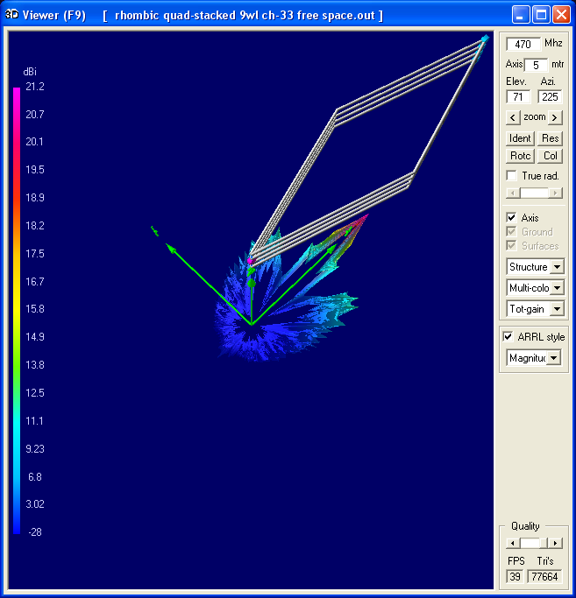
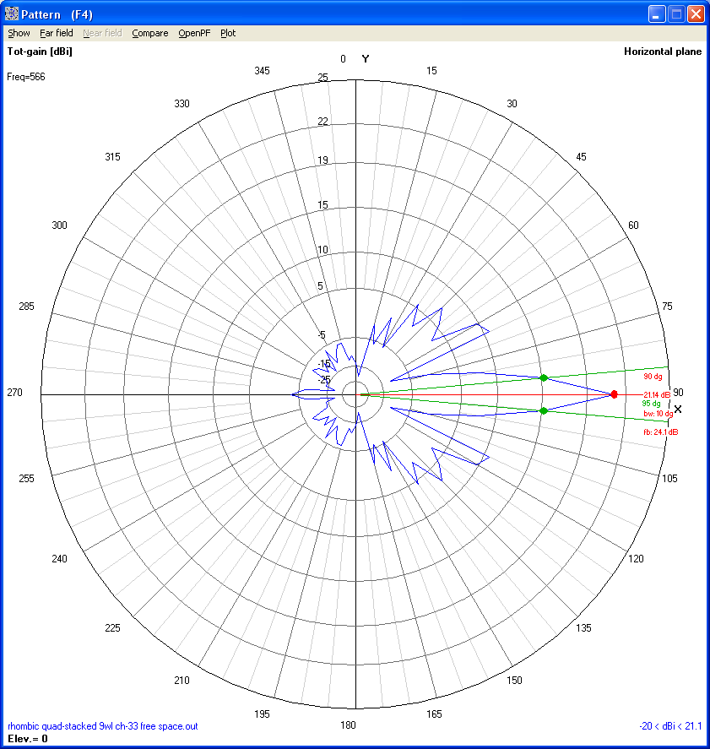
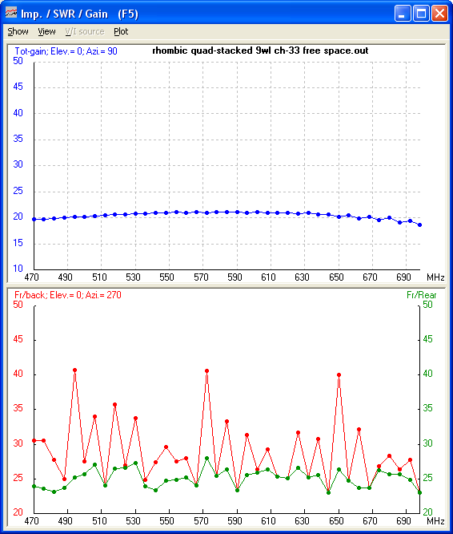
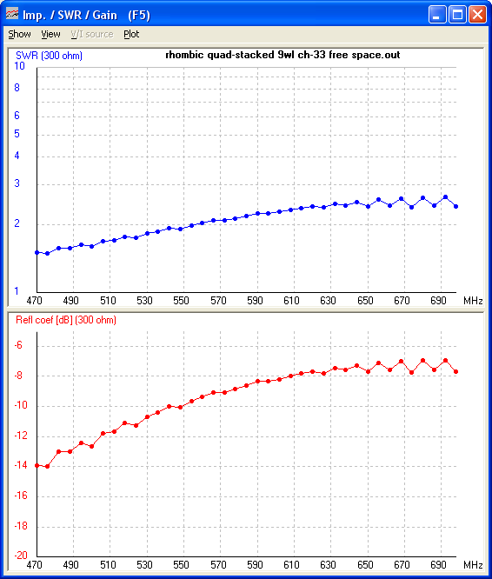
CM NEC Input File for Rhombic
CM Four stacked 9WL rhombic elements
CM Developed by GroundUrMast w / input from holl_ands re. FR and RP cards
CM 11/2011
CE
SY WL=0.64
SY LEG=9
SY LEGXSF=0.363364
SY LEGX=LEG-LEGXSF
SY LOAD=390
SY AGL=6
SY ENDG=0.020
GW 1 269 0 ENDG AGL LEGX*WL ((LEG*WL)^2-(LEGX*WL)^2)^0.5 AGL #12
GW 2 269 0 -ENDG AGL LEGX*WL -((LEG*WL)^2-(LEGX*WL)^2)^0.5 AGL #12
GW 3 269 LEGX*WL ((LEG*WL)^2-(LEGX*WL)^2)^0.5 AGL LEGX*WL*2 ENDG AGL #12
GW 4 269 LEGX*WL -((LEG*WL)^2-(LEGX*WL)^2)^0.5 AGL LEGX*WL*2 -ENDG AGL #12
GW 100 3 0 ENDG AGL 0 -ENDG AGL #14
GW 200 3 LEGX*WL*2 ENDG AGL LEGX*WL*2 -ENDG AGL #14
GW 11 269 0 ENDG AGL+WL*0.5 LEGX*WL ((LEG*WL)^2-(LEGX*WL)^2)^0.5 AGL+WL*0.5 #12
GW 12 269 0 -ENDG AGL+WL*0.5 LEGX*WL -((LEG*WL)^2-(LEGX*WL)^2)^0.5 AGL+WL*0.5 #12
GW 13 269 LEGX*WL ((LEG*WL)^2-(LEGX*WL)^2)^0.5 AGL+WL*0.5 LEGX*WL*2 ENDG AGL+WL*0.5 #12
GW 14 269 LEGX*WL -((LEG*WL)^2-(LEGX*WL)^2)^0.5 AGL+WL*0.5 LEGX*WL*2 -ENDG AGL+WL*0.5 #12
GW 110 3 0 ENDG AGL+WL*0.5 0 -ENDG AGL+WL*0.5 #14
GW 210 3 LEGX*WL*2 ENDG AGL+WL*0.5 LEGX*WL*2 -ENDG AGL+WL*0.5 #14
GW 21 269 0 ENDG AGL+WL LEGX*WL ((LEG*WL)^2-(LEGX*WL)^2)^0.5 AGL+WL #12
GW 22 269 0 -ENDG AGL+WL LEGX*WL -((LEG*WL)^2-(LEGX*WL)^2)^0.5 AGL+WL #12
GW 23 269 LEGX*WL ((LEG*WL)^2-(LEGX*WL)^2)^0.5 AGL+WL LEGX*WL*2 ENDG AGL+WL #12
GW 24 269 LEGX*WL -((LEG*WL)^2-(LEGX*WL)^2)^0.5 AGL+WL LEGX*WL*2 -ENDG AGL+WL #12
GW 120 3 0 ENDG AGL+WL 0 -ENDG AGL+WL #14
GW 220 3 LEGX*WL*2 ENDG AGL+WL LEGX*WL*2 -ENDG AGL+WL #14
GW 31 269 0 ENDG AGL+WL*1.5 LEGX*WL ((LEG*WL)^2-(LEGX*WL)^2)^0.5 AGL+WL*1.5 #12
GW 32 269 0 -ENDG AGL+WL*1.5 LEGX*WL -((LEG*WL)^2-(LEGX*WL)^2)^0.5 AGL+WL*1.5 #12
GW 33 269 LEGX*WL ((LEG*WL)^2-(LEGX*WL)^2)^0.5 AGL+WL*1.5 LEGX*WL*2 ENDG AGL+WL*1.5 #12
GW 34 269 LEGX*WL -((LEG*WL)^2-(LEGX*WL)^2)^0.5 AGL+WL*1.5 LEGX*WL*2 -ENDG AGL+WL*1.5 #12
GW 130 3 0 ENDG AGL+WL*1.5 0 -ENDG AGL+WL*1.5 #14
GW 230 3 LEGX*WL*2 ENDG AGL+WL*1.5 LEGX*WL*2 -ENDG AGL+WL*1.5 #14
GW 500 3 0 ENDG AGL+WL*0.75 0 -ENDG AGL+WL*0.75 #18
GE 0
LD 0 200 2 0 LOAD 0 0 0 0 0
LD 0 210 2 0 LOAD 0 0 0 0 0
LD 0 220 2 0 LOAD 0 0 0 0 0
LD 0 230 2 0 LOAD 0 0 0 0 0
LD 5 0 0 0 58000000
EK
EX 0 500 2 0 1 0 0
GN -1
TL 100 2 110 2 -450 0 0 0 0 0
TL 110 2 500 2 450 0 0 0 0 0
TL 500 2 120 2 450 0 0 0 0 0
TL 120 2 130 2 -450 0 0 0 0 0
' FR Freq Sweep choices in order of increasing calculation time (fm holl_ands):
' FR 0 0 0 0 585 0 ' Fixed Freq
' FR 0 29 0 0 470 12 ' Freq Sweep 470-806 every 12 MHz - OLD UHF BAND
' FR 0 34 0 0 410 12 ' Freq Sweep 410-806 every 12 MHz - Even Wider Sweep
FR 0 39 0 0 470 6 ' Freq Sweep 470-698 every 6 MHz - PREFERRED FOR UHF
' FR 0 77 0 0 470 3 ' Freq Sweep 470-698 every 3 MHz
' FR 0 153 0 0 470 1.5 ' Freq Sweep 470-698 every 1.5 MHz
' FR 0 71 0 0 300 10 ' Freq Sweep 300-1000 every 10 MHz - WIDEBAND SWEEP
' FR Hi-VHF choices:
' FR 0 15 0 0 174 3 ' Freq Sweep 174-216 every 3 MHz
' FR 0 29 0 0 174 1.5 ' Freq Sweep 174-216 every 1.5 MHz - PREFERRED
' FR 0 45 0 0 162 1.5 ' Freq Sweep 162-228 every 1.5 MHz - Add +/- 12 MHz BW
' FR 0 27 0 0 189 1.5 ' Freq Sweep 186-228 every 1.5 MHz - SPECIAL
' FR 0 43 0 0 174 1 ' Freq Sweep 174-216 every 1 MHz - Hi-Rez
' FR 0 23 0 0 198 1 ' Freq Sweep 198-220 every 1 MHz - Hi-Rez - Ch13 SPECIAL
' FR 0 26 0 0 150 6 ' Freq Sweep 150-300 every 6 MHz - WIDEBAND SWEEP
' FR Lo-VHF choices:
' FR 0 19 0 0 54 3 ' Frequency Sweep every 3 MHz for Ch2-6 + FM
' FR 0 35 0 0 54 1 ' Frequency Sweep every 1 MHz for Ch2-6
' FR 0 36 0 0 75 1 ' Frequency Sweep every 1 MHz for Ch5 + Ch6 + FM
' FR 0 28 0 0 54 6 ' Wide Freq Sweep every 6 MHz for Ch2-13
' FR 0 64 0 0 54 12 ' Super Wide Freq Sweep 54-810 every 12 MHz
' RP choices in order of increasing calculation time:
' RP 0 1 1 1510 90 90 1 1 0 0 ' 1D Gain toward 0-deg Azimuth - SIDE GAIN
' RP 0 1 1 1510 90 0 1 1 0 0 ' 1D Gain toward 90-deg Azimuth - FORWARD GAIN
' RP 0 1 1 1510 90 180 1 1 0 0 ' 1D Gain toward 270-deg Azimuth - REVERSE GAIN
' RP 0 1 37 1510 90 0 1 5 0 0 ' 2D (Left only) Azimuthal Gain Slice
RP 0 1 73 1510 90 0 1 5 0 0 ' 2D Azimuthal Gain Slice - PREFERRED
' RP 0 73 1 1510 90 0 5 1 0 0 ' 2D Elevation Gain Slice
' RP 0 73 73 1510 90 0 5 5 0 0 ' 3D Lower Hemisphere reveals antenna (Fixed Freq)
' RP 0 285 73 1510 90 0 5 5 0 0 ' 3D Full Coverage obscures antenna (Fixed Freq)
EN

