http://www.tvfool.com/?option=com_wrapper&Itemid=29&q=id%3d8e44510a7623f6

TV Signal Analysis Results
Here are the results for your location. The transmitter database was last updated on February 21, 2011. For more information about these plots and how to interpret them, please check out the Signal Analysis FAQ.
If you would like to share these results with others, this page can be referenced as:
http://www.tvfool.com/?option=com_wrapper&Itemid=29&q=id%3d8e44510a7623f6
To ask for help from other TV Fool members, post this link in a thread HERE.
To start over, click here.
Top of Form
Current
database:
All channels (save image)  Only Digital (save image)  Only Analog (save image) | These reports show what should be on the air now according to the latest FCC database.
Pending*  applications  included: | All channels (save image)  Only Digital (save image)  Only Analog (save image) | *These are speculative reports that include pending applications filed with the FCC. This lets you see the effect of planned upcoming transmitter changes, but note that things may change by the time the FCC finishes processing these applications.

HINT: You can see additional details about each transmitter by clicking on them in the table below.
If you notice any errors or omissions in the database, please report them HERE so that they can be corrected in future runs.
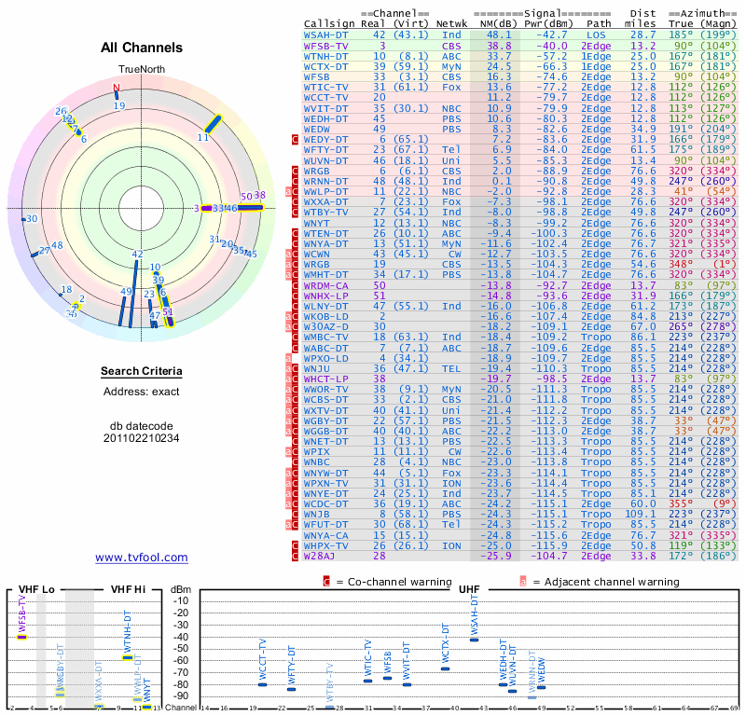
Bottom of Form
The Signal Analysis Report lists the broadcasters in your area, ranked from strongest to weakest, according to 3D propagation modeling of the location and height (optional) that you entered. The background color of each transmitter in the table is color coded as follows:
Background color | Estimated signal strength
Green | An indoor "set-top" antenna is probably sufficient to pick up these channels
Yellow | An attic-mounted antenna is probably needed to pick up channels at this level and above
Red | A roof-mounted antenna is probably needed to pick up channels at this level and above
Grey | These channels are very weak and will most likely require extreme measures to try and pick them up
Please understand that this is a simulation and can only be treated as a rough approximation. Reception at your location is affected by many factors such as multipath, antenna gain, receiver sensitivity, buildings, and trees - which are not taken into account. Your mileage may vary.

